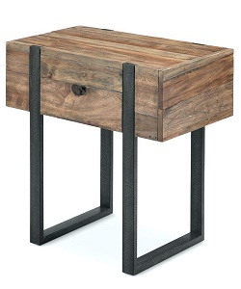

Simple End Table

$19.60

Availability: In stock

**Discription:**

Simple wood coffee end table with two iron rods. A clear striped glossy top provides a place for any items you want to show off, while boxy sled-style base below sports a sleek metallic finish for an on-tred look.this narrow design is perfect look for living room.Assembly is required.